

**CSE461**

**Project Report**

**Project Name: Automatic Firefighting Robot**

Group: 04

Section: 02

Submitted to: Shakir Rouf Sir & Niloy Irtisam Sir

Group Members:

● Adnan Sami - 20201011

● Mahzabin Hossain - 20301004

● S.K Mehedi Hasan Nayem- 20101194

● Poroma Biswas - 20201084

● Fardin Zaman - 20301473

**Introduction:**

Fire breakouts are unexpected disasters that bring about loss of lives, injury and property damage [1]. Furthermore, frequent breakouts can lead to far devastating effects such as environmental damage and also become an economic burden [1]. During fire breakouts oftentimes human intervention and resources are required. Thus, it can put the lives of humans at risk, as well as improper use of resources can cause more harm instead. However, with advancements and recent efforts in technology, it can be a viable option to implement robots which are capable of automatically detecting possible fire breakouts and preventing them before happening in the first place.

Problem statement: Can autonomous robots be a viable and resource efficient option for preventing fire breakouts ?

The answer to this question is yes, in our project we have developed a small scale robot, which is capable of autonomously detecting fire hazards and successfully neutralizing it with minimal use of resources. It has temperature and fire sensors and is able to move towards the fire source. Then, it is capable of spraying water and extinguishing the fire hazard. Overall, it makes our robot a viable tool for prevention of fire breakouts.

**Application area of project:**

Our robot is designed to constantly keep searching for any unexpected fire hazards and can be easily used in household areas, agriculture, industries or any areas where fires might have a high frequency of occurring. Once the robot is deployed its main function is to extinguish any possible fires during the initial phase to prevent a greater disaster from occurring.

**Video links for project our demonstration:**

Part -1 shows robot searching for a fire hazard:

<https://youtu.be/MkoUEX-YszI>

Part - 2 shows a robot using a water pump to extinguish fire hazard. Note - active fire hazard is not shown.

<https://youtu.be/lF82n1kG0Sc>

**Technology & tools (sensors & GPIO devices):**

|  |  |
| --- | --- |
| **Arduino Uno** | **Chassis with BO Motor and Wheels** |
| **IR flame sensor** | **L298 Motor Driver** |
| **Mini Breadboard** | **Servo motor** |
| **Relay module (1 channel)** | **Infrared Non-contact temperature sensor (mlx90614)** |
| **DC Pump Motor** | **Battery** |
| **Battery holder** | **Wires** |

**Software Used:**

→ Arduino IDE

Other equipments:

→Hot Glue Gun

→Double sided tape

→Screwdriver

→Water container

→Water Pipe

**Description of the microcontroller, sensors, actuators we used:**

**Arduino Uno :** The Arduino Uno is a famous microcontroller board known for its ease of use and versatility in electronics prototyping and DIY applications. It has an easy-to-use interface and an array of digital and analog input/output pins, making it possible to link with a variety of sensors, actuators, and other electronics. It is open-source, with a strong community support system [2].

**IR Flame Sensor:** or Fire Sensor detects the infrared radiation released by flames. The infrared sensor converts radiation into an electrical signal, which is subsequently amplified and processed. If the signal exceeds a specified threshold, the sensor alerts or does further actions to identify a fire or flame [3].

**Infrared Non-contact temperature sensor (mlx90614):** The MLX90614 is an infrared non-contact temperature sensor that detects infrared light produced from an object's surface and uses that to determine its temperature. The sensor has an infrared thermopile detector, which absorbs infrared radiation and produces a voltage signal. Which is turned into electrical signals and used to measure temperature without touching the object. In our project, it basically works to detect high temperatures of flame or potential heat related hazards [4].

**A servo motor:** A servo motor operates through using a control signal to accurately position its output shaft. The motor contains a DC motor, gears, and a feedback system. The control signal, usually a pulse-width modulation (PWM) signal, sets the angle at which the shaft rotates by changing the position of the internal gears, providing precise and controlled movement. For our project it is used to swing the water pipe at different angles [5].

**BO motor:** These motors act as actuators to move the robot towards the fire. The motors can adjust their rotational speed to move fast or slow and even take left or right turns.

**DC water pump:** This pump consists of a high speed rotating impeller which utilizes kinetic energy and hydrodynamic forces to move water at high speed and pressure out of its nozzle.

**Circuit diagram:**

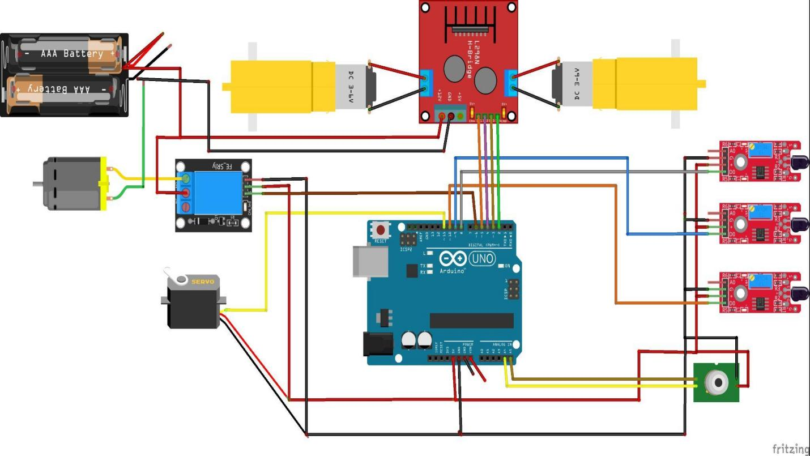

**Code:**

//Fire Fighting Robot using MLX 90614 by CSE461 group 4

#include <Wire.h>

#include <Servo.h>

#include <Adafruit_MLX90614.h>

Adafruit_MLX90614 mlx;

Servo myservo;

#define Left 8

#define Right 9

#define Forward 10

#define LM1 2

#define LM2 3

#define RM1 4

#define RM2 5

#define pump 6

void setup() {

pinMode(Left, INPUT);

pinMode(Right, INPUT);

pinMode(Forward, INPUT);

pinMode(LM1, OUTPUT);

pinMode(LM2, OUTPUT);

pinMode(RM1, OUTPUT);

pinMode(RM2, OUTPUT);

pinMode(pump, OUTPUT);

mlx.begin();

myservo.attach(11);

myservo.write(90);

}

void sweepServo() {

for (int pos = 50; pos <= 130; pos += 1) {

myservo.write(pos);

delay(10);

}

for (int pos = 130; pos >= 50; pos -= 1) {

myservo.write(pos);

delay(10);

}

}

void put_off_fire() {

digitalWrite(LM1, LOW);

digitalWrite(LM2, LOW);

digitalWrite(RM1, LOW);

digitalWrite(RM2, LOW);

digitalWrite(pump, HIGH);

sweepServo(); // Sweep the servo while extinguishing the fire

digitalWrite(pump, LOW);

}

void loop() {

double temp = mlx.readObjectTempC();

if (temp > 37.0) {

put_off_fire();

} else {

myservo.write(90); // Center the servo

int leftSensor = digitalRead(Left);

int rightSensor = digitalRead(Right);

int forwardSensor = digitalRead(Forward);

if (leftSensor && rightSensor && forwardSensor) {

digitalWrite(LM1, HIGH);

digitalWrite(LM2, HIGH);

digitalWrite(RM1, HIGH);

digitalWrite(RM2, HIGH);

} else {

// Stop and adjust movement based on sensor inputs

digitalWrite(LM1, HIGH);

digitalWrite(LM2, LOW);

digitalWrite(RM1, HIGH);

digitalWrite(RM2, LOW);

if (leftSensor == LOW) {

// Turn left

digitalWrite(LM1, HIGH);

digitalWrite(LM2, LOW);

digitalWrite(RM1, HIGH);

digitalWrite(RM2, HIGH);

}

if (rightSensor == LOW) {

// Turn right

digitalWrite(LM1, HIGH);

digitalWrite(LM2, HIGH);

digitalWrite(RM1, HIGH);

digitalWrite(RM2, LOW);

}

}

}

**Data flow diagram:**

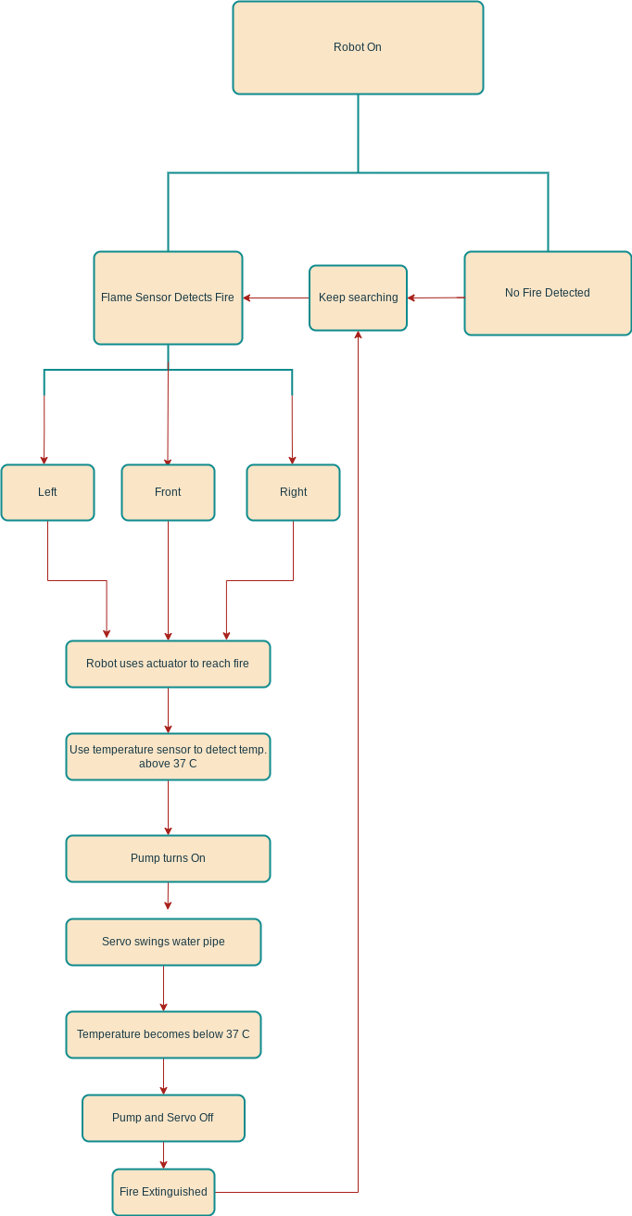

**Future Aspects:**

→ Ideal for use in household and industrial areas to prevent fire related accidents.

→ Can be used in forests and agriculture to prevent natural forest fires.

→ Add features like gas detection, calling owners or firefighters, in case of larger breakouts.

→ Helps to reduce use of natural resources and provide good economic viability.

**Conclusion:**

Our Firefighting robot makes for an ideal solution to prevent fire hazards without putting human lives at risk or potential injury. It is economically viable and implementing robots like this may significantly bring down the chances of fire accidents or hazards. It has a simple yet effective design and working principle and thus can be applied in a wide range of areas from households to industries. As the robot uses water based fire extinguishing, it cuts down the need of other toxic fire extinguishing chemicals and thus is environmentally friendly as well. However, there are some aspects which might hinder its performance which include its limited range, size and its inability to deal with large amounts of fire. Nevertheless, this autonomous robot holds the ability to prevent massive fires from ever occurring in the first place. Thus saving lives, preventing property destruction from fire and its economical savings easily overshadow its shortcomings and makes it a viable tool to be used in our everyday lives.

**References:**

[1]*The power of fire*. (n.d.). The Hartford. Retrieved April 27, 2024, from https://www.thehartford.com/about-us/junior-fire-marshal/the-power-of-fire

[2] D’Ausilio, A. Arduino: A low-cost multipurpose lab equipment. *Behav Res* 44, 305–313 (2012). <https://doi.org/10.3758/s13428-011-0163-z>

[3] *IR Infrared Flame Sensor Module*. (n.d.). Electropeak.com. Retrieved April 27, 2024, from <https://electropeak.com/flame-sensor>.

[4] *MLX90614 non-contact IR temperature sensor*. (n.d.). Components101. Retrieved April 27, 2024, from https://components101.com/sensors/melexis-mlx90614-contact-less-ir-temperature-sensor

[5] *What is a Servo Motor? - Understanding the basics of Servo Motor Working*. (n.d.). Circuitdigest.com. Retrieved April 27, 2024, from https://circuitdigest.com/article/servo-motor-working-and-basics